THE RELATIVE VALUE OF PIECES

In practice, the value of a piece may increase or decrease depending on its mobility, fighting power and co-ordination with other pieces. We will analyse the following games:
Game 1

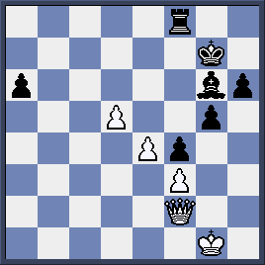
Here both sides have the number of points:
White: Queen (9 pts) +3 pawns (3 pts) = 12 pts
Black: Rook (5 pts) +Bishop (3 pts) +4 pawns (4 pts)= 12 pts
So they have the same absolute value.

However, White Queen is powerful, White e and d pawns can march on to promote.Black Bishop can hardly play, King is exposed, pawn a6 is loose and easily caught.White is much better if we consider relative value.

Game 2

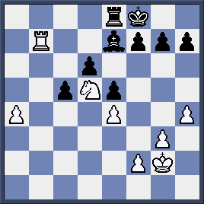
Materially, White is a point down (W: R+N+5 ps vs B: R+B+6 ps) but he has a better position: his Rook is attacking on 7th rank, his Knight is well placed at the center, his a-pawn is on the way to make a new Queen.Black, meanwhile, has a poor

Bishop, blockaded pawns, tied Rook and weak King.He has to face the difficult task of stopping White a-pawn.Thus, White is winning positionally.

Quiz:
White to play.Which side would you prefer?

